

📱Course: AKM – 401

MODULE: THE CLOUD PIERCER (Radar Exploration)

Status: Level 4 (Expert) | XP Reward: 1200 XP | Badge: The Radar Tech

👋 Welcome to the Expert Level!

Most prospectors stop working when the rains come. Clouds block the sun, so normal satellites go blind. But Synthetic Aperture Radar (SAR) does not need sunlight. It shoots its own energy beams through the clouds to map the ground day or night, rain or shine.

Your Mission: Learn to interpret Radar images on the NMIH Dashboard to identify geological faults and structures hidden by bad weather.

UNIT 1: SEEING THE INVISIBLE (How Radar Works)

Active vs. Passive Sensing.
1. The "Bat" Principle
Normal satellites (Optical) are like eyes—they need the sun to see.
Radar satellites are like Bats. They send out a "ping" (Microwave pulse) and listen for the echo.

- The Benefit: Microwaves pass straight through clouds, smoke, and rain.
2. Texture, Not Colour
Radar does not see "Green" or "Red." It sees Roughness.
- Rough Surfaces: Scatter the energy back to the sensor. They appear BRIGHT on the map (e.g., rocky outcrops, ridges, coarse vegetation).
- Smooth Surfaces: Reflect the energy away like a mirror. They appear DARK (e.g., tarred roads, calm water, flat airstrips).

Caption: To Radar, a calm lake is black, but a rocky hill is bright white.

UNIT 2: FINDING FAULTS IN THE RAIN

Why wet soil helps you.
1. Structural Geology
Minerals like Gold often form in Faults (cracks in the earth's crust).
- Radar's Superpower: Because Radar sees "texture," it highlights straight lines on the ground very clearly. A long, straight geological crack (lineament) that is invisible to the eye often glows on a Radar map.

2. The Dielectric Effect (Wet Ground)
Radar is sensitive to water content.
- When the ground is wet, the "electrical" properties of the soil change. This allows Radar to penetrate the top layer of dry sand and "see" the rock structure underneath.
- Pro Tip: The best time to scan for faults is often just after a storm.

UNIT 3: INTERPRETING THE IMAGE

Reading the Black & White Map.

1. The "Bright Line"
If you see a sharp, bright line cutting across the landscape on the Radar layer:
- Possibility A: A fence or powerline (Man-made).
- Possibility B: A geological Dyke or Fault (Nature).
- Action: Check the optical map. If you can't see it there, it’s likely a buried geological structure.

2. The "Dark Spot"
- A pitch-black patch usually means water or a very flat tailings dam.
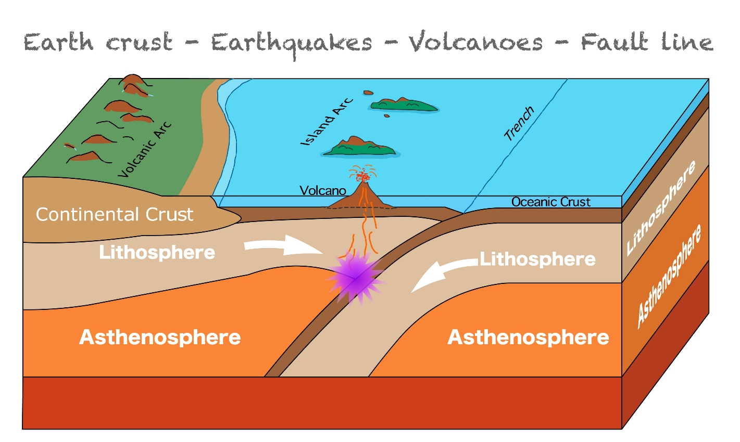
Shutterstock

🏆 FIELD CHALLENGE (The Gig)

Complete this task to earn your "Radar Tech" Badge.

Task: The Texture Hunt
- Open the NMIH App and switch the layer to "Radar / SAR Mode" (Black & White view).
- Find an area on the map that looks Very Bright (Rough) and an area that looks Very Dark (Smooth).
- Walk to the "Bright" zone.
- Verify: Is it a rocky outcrop? A dense forest? Or a building?
- Tag it: "Ground Truth: Rocky Outcrop causing Radar Backscatter."

[BUTTON: VERIFY RADAR SIGNATURE]

📝 QUIZ: THE ALL-WEATHER MINER

Module: AKM-401 | Time Limit: 5 Mins | Pass Mark: 4/5

Q1: What is the main advantage of Radar (SAR) satellites over Optical satellites?
A) They can see through clouds, rain, and smoke, allowing exploration all year round.
B) They take color photos.
C) They are cheaper.
D) They can find plastic.
Q2: Radar images don't show color. Instead, brightness in a Radar image usually represents:
A) The temperature.
B) Surface Roughness (Texture).
C) The amount of gold.
D) The time of day.
Q3: How does a very smooth surface (like a calm dam or a tarred road) appear on a Radar map?
A) Bright White.
B) Dark / Black (because it reflects the signal away).
C) Red.
D) Flashing.
Q4: Why is Radar particularly good at finding "Geological Faults"?
A) It can hear the cracks moving.
B) It highlights linear structures and texture changes in the earth's crust better than optical cameras.
C) It digs the hole for you.
D) It uses X-rays.
Q5: "Active Sensing" means:
A) The satellite waits for sunlight.
B) The satellite sends out its own energy pulse (microwave) and measures the echo.
C) The satellite moves fast.
D) The miner must run while using it.

SUBMIT ANSWERS & CLAIM 1200 XP

